Answer any three out of four questions.

1. a) Represent the following Wumpus world by propositional logic (PL). Your knowledge base should contain generic rules e.g. nearby squares having breeze have pit, as well as facts of breeze and stench. From that KB conclude that P3,1 has the Wumpus. Show the steps of your conclusion. 3+5

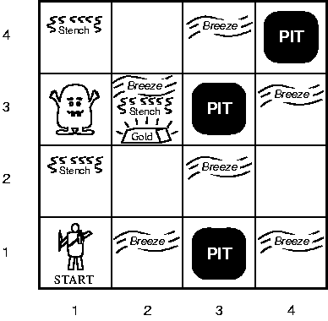

b) Write short notes on forward chaining and backward chaining of inference algorithms. Which one will you prefer if you are asked to choose one as one of your inference algorithms? Justify your answer. 7

1. a) What is Horn clause? Why it is important to use to represent knowledge base (KB)? Prolog uses Horn Clauses for its KB. Is it true or false? Justify your answer. 3+4

b) Translate the following sentences into FOL sentences then infer the KB to find the answer by resolution. 4+4

Jack owns a dog.

Every dog owner is an animal lover.

No animal lover kills an animal.

Either Jack or Curiosity killed the cat, who is named Tuna.

Did Curiosity kill the cat?

1. a) Briefly discuss supervised learning vs unsupervised learning, over fitting problem in machine learning and different ways of pruning decision tree. 9

b) What is entropy? Why it is used to classify data in ID3 algorithm? 6

1. a) Suppose we want to classify potential bank customers as good creditors or bad creditors for loan applications. We have a training dataset describing past customers using the following attributes: Marital status {married, single, divorced}, Gender {male, female}, Age {[18..30], [30..50], [50..65], [65+]}, Income {[10K..25K], [25K..50K], [50K..65K], [65K..100K], [100K+]}.

***Draw neural network architecture for the above problem***. 5

b) Given the following neural network with initialized weights as in the picture, explain the network architecture knowing that we are trying to distinguish between dogs and cats and an example of training tupples is as follows: T1{0.6, 0.1, dog}, T2{0.2, 0.3, cat}. 10

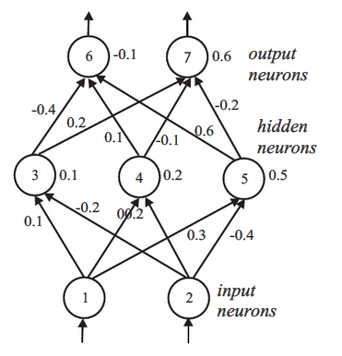

Let the learning rate ŋ be 0.1 and the weights be as indicated in the figure above. Do the forward propagation of the signals in the network using T1 as input, then perform the back propagation of the error. Show the changes of the weights.

Hint: Encoding of the outputs may be 10 for class “dog”, 01 for class “cat”